Project Name- GIS based Micro Plan Preparation for Titilagarh, Saharapada, and Thakurmunda Block of Odisha
Objective:
The broad objective is to Prepare GIS Based Micro Planning for Titilagarh, Saharpada and Thakurmunda Block (selected GP and Villages) of Odisha
The Specific Objectives are as Follows
-Creation of Village Base Map using GIS and RS Technology
-Creation of Land use and Landcover Map of Selected Villages
-Creation of Drainage Network Map of Selected Village
-Creation of Soil and Slop Map of selected villages
-Creation of Thematic Maps for Micro Planning Preparation
-Creation of Proposed Micro Plan in consultation with Villagers/Community
-App Development for GIS based Micro Plan
Methodology:
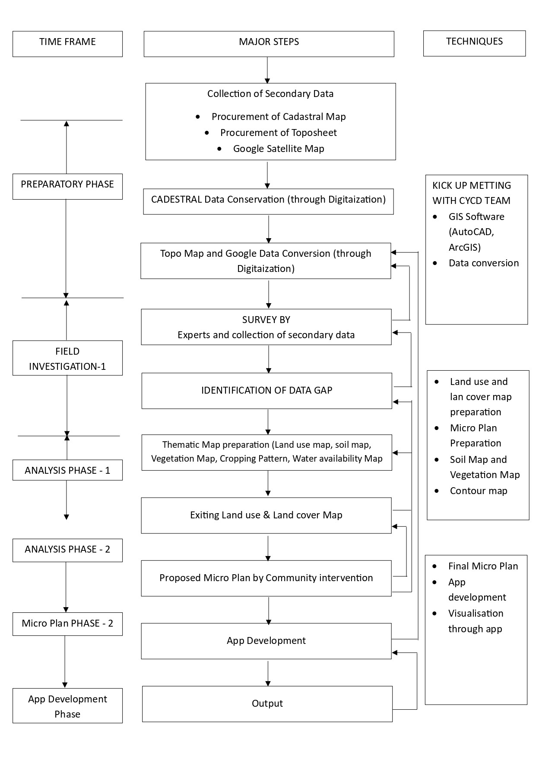
Field Based Micro Plan:
